|  |  |
| --- | --- |
| **Ex No: 6**  **Date: 04-09-2024** | **Transfer learning in image classification** |

**Objective:**

The objective of this lab exercise is to implement an image classification model using EfficientNet, a popular deep learning model, to classify flower images into five categories: roses, daisies, dandelions, sunflowers, and tulips. The dataset used is the Flower Photos dataset, and the implementation is carried out using TensorFlow and TensorFlow Hub.

**Descriptions:**

**Download and Extract Dataset:**

* The dataset containing flower images is downloaded from the TensorFlow storage
* URL: https://storage.googleapis.com/download.tensorflow.org/example_images/flower_photos.tgz.
* The dataset is extracted using TensorFlow’s tf.keras.utils.get_file method. The dataset is stored in the current working directory.

**Dataset Exploration:**

* The dataset is organized into subfolders for each flower category: roses, daisy, dandelion, sunflowers, and tulips.
* The code lists a few images from each category and checks the total number of images to ensure the dataset is correctly downloaded and extracted.

**Image Loading and Preprocessing:**

* Images are loaded from their respective directories (roses, daisy, etc.) and resized to 224x224 pixels.
* The images are stored in arrays X (features) and y (labels), where each label corresponds to a flower category.
* Images are scaled to the range [0, 1] by dividing pixel values by 255.

**Data Splitting:**

* The dataset is split into training and test sets using train_test_split from scikit-learn.
* The training and testing datasets are further scaled to the [0, 1] range.

**Model Definition:**

* An EfficientNet model is used as a feature extractor. The EfficientNet model is loaded from TensorFlow Hub with the URL https://tfhub.dev/google/efficientnet/b0/feature-vector/1.
* A Keras model is created by appending a dense layer on top of the EfficientNet feature extractor.

**Model Compilation and Training:**

* The model is compiled using the Adam optimizer and SparseCategoricalCrossentropy loss function.
* The model is trained on the scaled training dataset for 5 epochs.

**Model Evaluation:**

* A function is defined to preprocess test images by resizing and normalizing them.
* The model is tested with a new image to predict its class. The prediction is outputted and mapped to the corresponding flower name.

#### Results:

* The model is trained on the Flower Photos dataset and successfully predicts the class of new flower images.
* Predictions are printed, showing the predicted flower category for the test image.

**Model Architecture:**

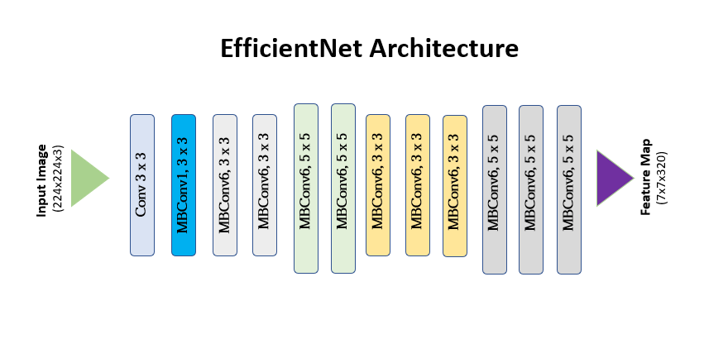

**Model summary:**

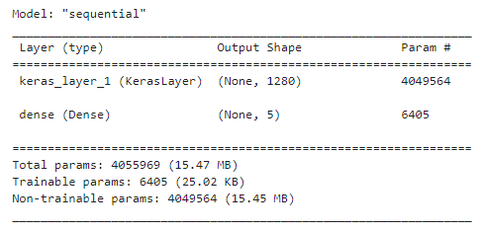

**Variations done:**

Used Efficientnet model from TensorFlow Hub and trained the model on the flowers dataset.

**Github Link:**

**https://github.com/Bhargava-Srinivasan-26/Deep_learning_elective/tree/main/Unit%201/Lab%205**